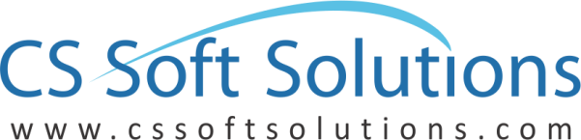
Logo Design Questionnaire
-----------------------------------------------------------------------------------------------------------------------------
Name of the Customer: Mohammed ALOthaim Holding
Date:
Project Title: URFX
- Please write exactly your company name on which logo need to be make. Do mention upper and lower case scenarios.
URFX ( UR FIXES)

- How would you describe your services and/or products?
Services, property maintenance

- What’s the average age range of your target customer base?
Starting from 22 years old and older up

- Do you have a tag line, motto or slogan? If so, would you like it stated alongside your logo?
Wo do but it will not be with the logo for now.

- Do you have any specific imagery in mind for your logo?
Yes attached.

- Do you have any color preferences, or existing brand colors?
No but strong contract for more attention getting

- Do you have any colors that you do not wish to use?
Bright colors like light blue or light green

- What adjectives should best describe your logo?
What do you mean?

- What feeling or message do you want your logo to convey to those who view it?
Read company profile by just looking at the logo

- Where will the logo be used? On web, print etc?
all

- Please list some of your favorite logo whose characteristics you would like to incorporate into the logo. Briefly explain what aspects of the logo do you like?
NA

- Would you like any addition design services to be packaged with your new logo, like designs for letterhead, business card & envelope?
no

Note: Please give your some time to answers these questions, this will help us to understand your design needs and we will be able to provide you our best in same terms.

